PRD for Vendor Selection Logic
Contents
1. Problem Statement 2
2. Solution Overview 2
2.1 Assumptions 2
2.2.1 Vendor Definition 2
2.2.1.a Profile: 2
2.2.1.b Rates definition: 3
2.2.2 Vendor Selection 5
2.2.2.a Arriving on serviceable carrier based on below parameters: 5
2.2.2.b Selection Logic: 8
2.2.3 Blacklisting Various parameters: 9
2.2.3.a Blocking a Seller 9
2.2.3.b Blocking a Buyer 9
2.2.2.c Blocking a drop Pin code 9
2.2.2.d Blocking a pickup pin code 10
2.2.4 Serviceability Dashboards 10
2.2.4.a Serviceability without Order ID 10
2.2.4.b Serviceability by Order ID 10
2.2.4.c Post shipment booking (& re-booking) details to be captured: 11
3. Success Matric 13

Problem Statement
Currently the system can’t calculate the logistics cost of a shipment in most correct manner. This causes incorrect allocation which may not be cost optimal.

Solution Overview

Assumptions
- Vendor is defined as any entity that would pickup & deliver shipment against an Order for us.
- This document shall only deal with vendors operating in Intercity categories (non-grocery) with us.
- We would focus not only on the selection part but overall, i.e. vendor definition, vendor selection & vendor performance.
- Phase 1: Selection of vendor would be basis cost & transit time. Transit time would be static & would not get revised basis past performance.
- Phase 2: Additional parameters such as pickup performance, delivery performance and dynamically calculated transit time would be considered for shipment allocation.

2.2.1 Vendor Definition

2.2.1.a Profile:
  - A user would be able to define a new vendor in the system by entering following details:
    - Vendor Name
    - Service Name
    - Vendor GSTN
    - Registered Address of Vendor
    - Service Type: Air/Ground
    - Supported MOP: Credit Cards/Debit Cards/COD/UPI
    - COD Limit (INR)
      - Min.
      - Max.
    - Weight capacity (kg)
      - Min.
      - Max.
    - Material that can be shipped: Normal/Flammable/Fragile
    - Product Categories served: Footwear/HF/Toys/Apparel/CE
      - Invoice Value (INR - for each Product category)
        - Min.
        - Max.
    - Movement supported: Forward/Reverse/Both
    - Volumetric weight Factor
    - Account Name (not in FE)
    - API key staging (not in FE)
    - API key prod (not in FE)
    - Weight capacity of service (min. & max.) [not in FE]

2.2.1.b Rates definition:
- A user will be able to define following rates for a vendor.
- Shipment Level charges:
- LR Charges
- Max (Rs xx, yy % of Calculated cost)
- Priority
- Fuel Surcharge
- Max (Rs xx, yy % of calculated cost)
- Priority
- ODA Charges
- Max (Rs xx, yy % of calculated cost)
- Pin codes for ODA
- Priority
- ROV Insurance
- Max (Rs xx, yy % of calculated cost)
- Priority
- COD Charges
- Max (Rs xx, yy % of calculated cost)
- Priority
- RAS Charges
- Max (Rs xx, yy % of calculated cost)
- Pin codes for RAS
- Priority
- Handling charges
- Slab (basis weight) based charges
- Max (Rs xx, yy % of calculated cost)
- Priority
- Green Tax
- Slab (basis weight) based charges
- Max (Rs xx, yy % of calculated cost)
- Area pin code
- Priority
- Miscellaneous 1
- Max (Rs xx, yy % of calculated cost)
- Priority
- Miscellaneous 2
- Max (Rs xx, yy % of calculated cost)
- Priority
- Miscellaneous 3
- Max (Rs xx, yy % of calculated cost)
- Priority
- Discount (% on total calculated cost)
- Other Charges
- Demurrage Charges
- Max (Rs xx, yy % of calculated cost)
- Priority
- Demurrage free area
- Holiday Delivery (to be discussed with Nitesh)
- Max (Rs xx, yy % of calculated cost)
- Define holiday on a calendar
- Priority

- Re-attempt charges
- No. of free attempts
- Rs per attempt
- Priority

    - Lane Rates & time
      - Choose a rate card format:
        - Format 1 (Blue Dart format)
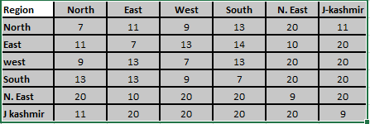
        - Format 2 (Delhivery B2B format)
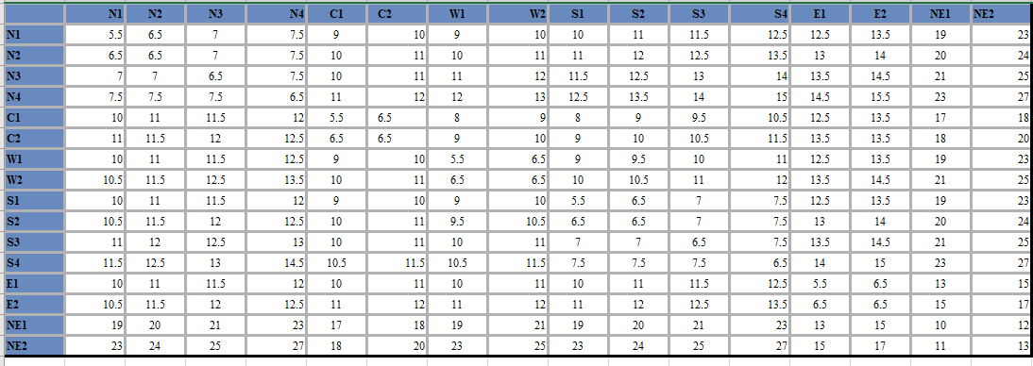
        - Format 3 (XB format)
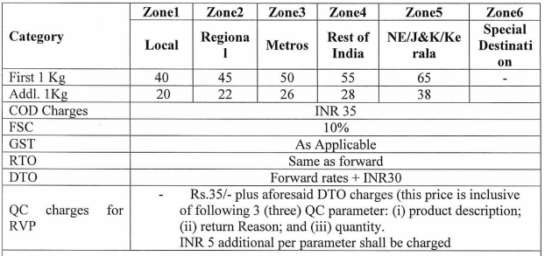
        - Format 4 (Gati Format)
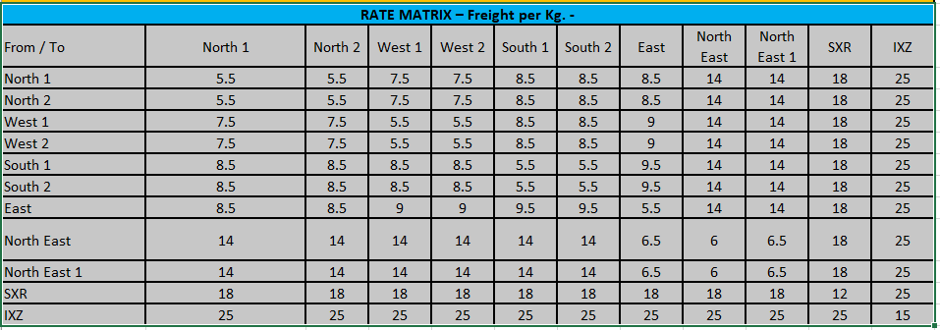

      - Upload rates:
        - Users will be able to download a format & upload lane rate & time for same.

2.2.2 Vendor Selection
For a given shipment, system will choose a vendor basis ranking. Ranking would be calculated based on several user-entered parameters.

2.2.2.a Arriving on serviceable carrier based on below parameters:

- Basis serviceability
- Basis serviceable weight
- Basis COD Limit
- Basis Invoice Value
- Basis Product Categories
- Basis blocked sellers.
- Basis blocked buyers.
- Basis blocked pin codes.
- No. of parcels

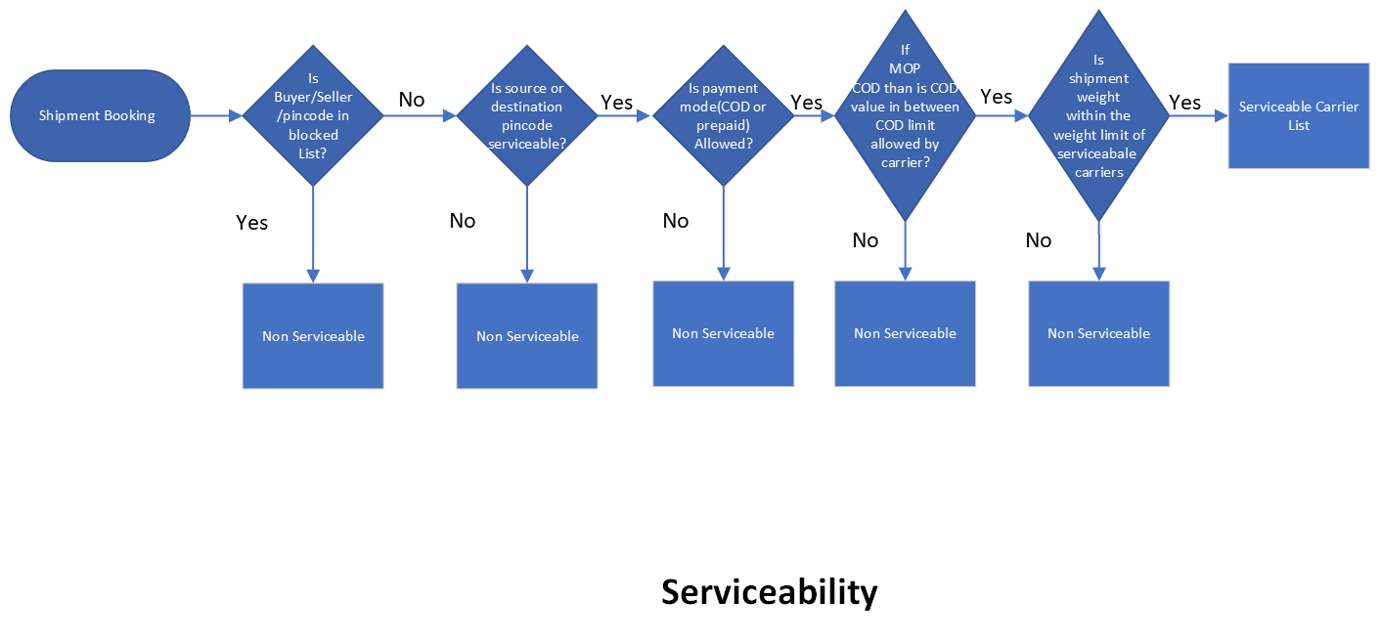
Phase 1
Vendor Selection Process (sharepoint.com)
Priority load Allocation
Carrier & Service | Buyer Solv ID | Buyer address ID | Seller Solv ID | Seller WH ID
Blue Dart -etailground | Afdaf | AD1 | ASG54 | WH1, WH2
DL- B2B | Afdaf
XB | Afdaf |  | ASG54
If any carrier is prioritized for a set of buyer/sellers, system will try to allocate orders from that buyer/seller to a particular carrier. For example:
For Seller Solv ID “ASG54” & WH1 &2, system will try to allocate load to BD-etailground. If there’s any error while shipment booking, system will go to ranking logic and allocate the order.
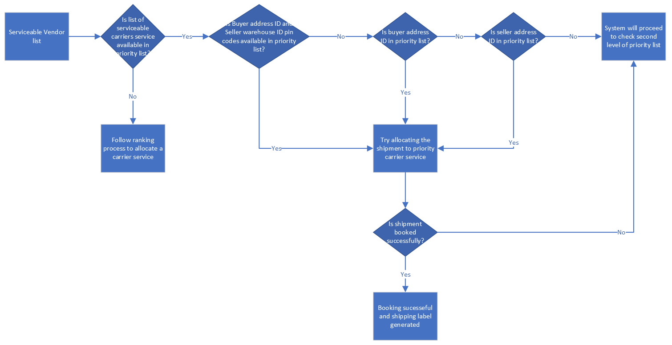
Carrier & Service | Drop Pin code | Pickup Pin code | Product Category | Min. Weight | Max. Weight
Blue Dart -etailground | 560100 | 110011 | HF | 20kg | 50kg
DL- B2B
If priority load allocation logic is present for a service, other logics would get by-passed and system would allocate load to that carrier-service. For example:
All HF shipments ranging within 20-50 kg from Pin code 110011 to 560100 would be allocated to BD-etailground service, provided it is serviceable. If serviceability isn’t there, the system will follow cost/time-based logic.
If a user has entered same category with different vendor service with conflicting weight range with another entry then system will check ranking logic for these vendor services and will allocate the lowest rank vendor service from these 2 vendor service.
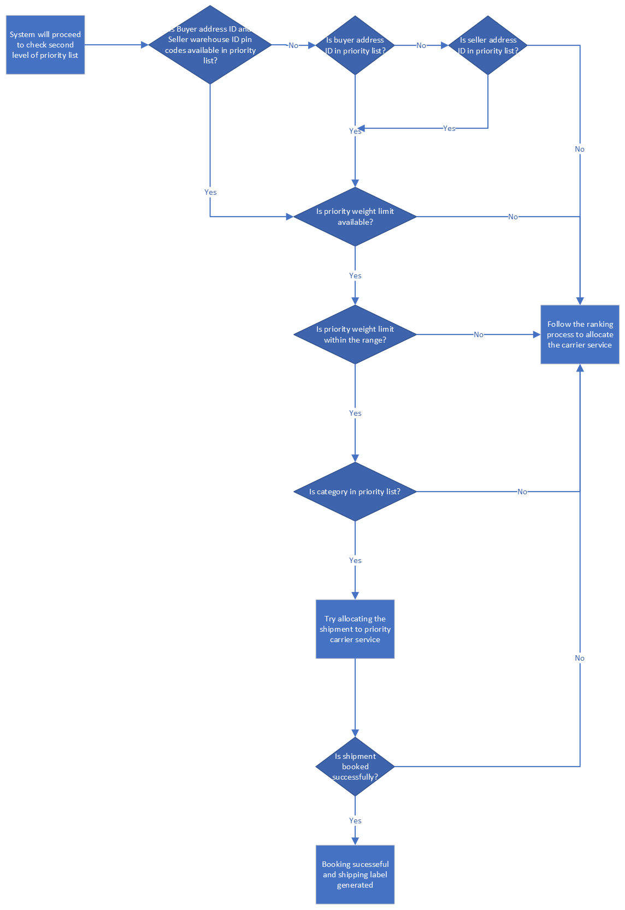

Limit Load Allocation
Drop Pincode | Delivery B2B | Bluedart etail ground | Xpressbees | Ekart large
560100 | 100 | 50 | 50 | 20
560003 | 100 | 50 | 50 | 20
560004 | 100 | 50 | 50 | 20
560005 | 100 | 50 | 50 | 20
Users will be able to define the load at drop pincode level for each vendor service.
If limit load allocation logic is present, system would limit the allocation as per defined rules. For example:
The system would not allocate more than 50 orders to Bluedart etail ground for drop pincode 560100 on a daily basis. System will allocate the 50 orders to Bluedart etailground for this pincode based on priority logic. If there is 51st order from this pincode on given day then system will move to the ranking logic and will allocate the lowest rank vendor service.
If all available vendor service load is breached than system will allocate the order to bluedart etail ground only.
Defining weightage for cost & time:
Weightage for parameters will be input by user in serviceability screen. Weightage will differ based on category. While entering the weightage for all parameters the user has to select the category.
Parameters | Weightage (user-defined) | Category
Cost | 70% | HF/Footwear/Toys/CE/Apparels
Time | 30% | HF/Footwear/Toys/CE/Apparels

Phase 2
Parameters basis which the system would allocate orders in phase 2 would be following:
Parameters | Weightage (user-defined) | Category
Cost | 60% | HF/Footwear/Toys/CE/Apparels
Time | 20% | HF/Footwear/Toys/CE/Apparels
Pickup Performance | 10% | HF/Footwear/Toys/CE/Apparels
Delivery Performance | 10% | HF/Footwear/Toys/CE/Apparels

2.2.2.b Selection Logic:
System will first derive a serviceable carrier list basis various parameters listed in 2.2.2.a. Once list is arrived, system will check priority load allocation logic. If any carrier is present in priority list, system will try to book the order with priority vendor provided daily/monthly limit for that vendor isn’t exhausted.
If there’s no priority vendor, then system will calculate the ranking basis cost & time for serviceable vendors. System will check if lowest ranked vendor hasn’t exhausted the daily/monthly allocation capacity. If capacity isn’t exhausted, system will book lowest ranked vendor else it will choose next ranked vendor. However, if there’s only one vendor serviceable & it’s daily/monthly allocation capacity is exhausted, system will still book with that vendor.
Following is an example for ranking calculation basis Phase 1:
Carrier | Calculated Cost | Relative Cost Rating (A) | Calculated Time | Relative Time Rating (B) | Final Rating  (A) x 0.7 + (B) x 0.3 | Rank
BD | 100 | 0.77 | 4 | 1 | 0.84 | 5
DL | 105 | 0.81 | 3 | 0.75 | 0.79 | 3
XB | 90 | 0.69 | 4 | 1 | 0.78 | 2
DL B2B | 101 | 0.78 | 2 | 0.5 | 0.69 | 1
Smartr | 120 | 0.92 | 2 | 0.5 | 0.80 | 4
Gati | 130 | 1.00 | 2 | 0.5 | 0.85 | 6
System will choose DL B2B in above example.
If final rating of two vendors is same, one with lowest cost will be chosen. If cost is also same one with min. time will be chosen. If time is also same, randomly system will choose.
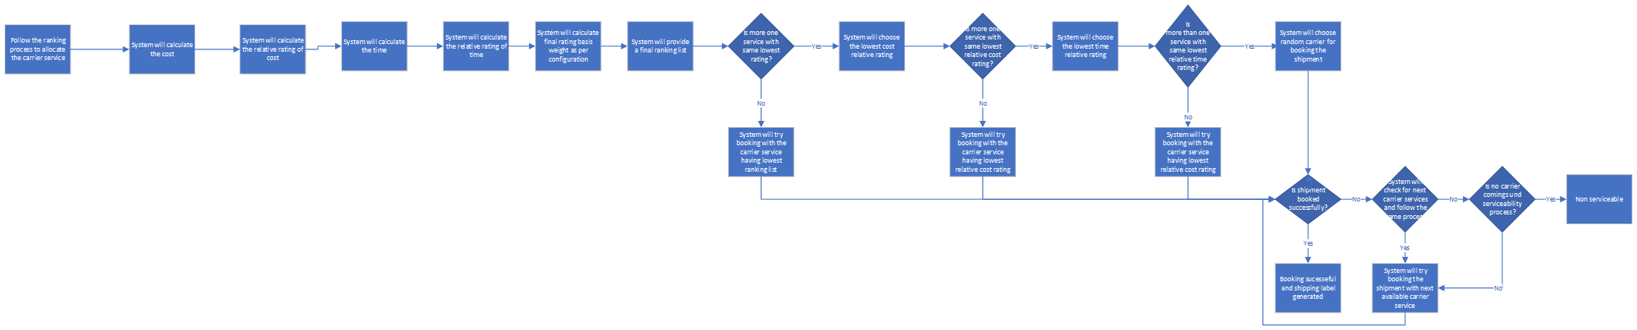

2.2.3 Blacklisting Various parameters:
Users can blacklist Sellers/Buyer/pin codes for a vendor.

2.2.3.a Blocking a Seller
Following will be the format:
Block a Seller (This will mean, all sellers in this list will be unserviceable for marked vendor, however they’ll be able to buy products on platform and as a buyer they’ll be serviceable)
Solv ID | Warehouse | BD | DL | XB | DL B2B | Smartr | Gati
Solv123 | ALL | Yes | Yes | Yes | Yes | Yes | Yes
Solv122 | WarehouseID1,  WarehouseID2 | No | Yes | No | Yes | Yes | No
Solv125 | WarhouseID2 | Yes | No | Yes | No | Yes | Yes
Solv124 | WarhouseID1 | Yes | Yes | Yes | Yes | Yes | Yes

2.2.3.b Blocking a Buyer
Following will be the format:
Block a buyer (This will mean, all buyer in this list will be unserviceable for marked vendor, however they’ll be able to sell products on platform and as a seller they’ll be serviceable)
Solv ID | Address ID | BD | DL | XB | DL B2B | Smartr | Gati
Solv123 | All | Yes | Yes | Yes | Yes | Yes | Yes
Solv122 | AD1, AD2 | No | Yes | No | Yes | Yes | No
Solv125 | AD2 | Yes | No | Yes | No | Yes | Yes
Solv124 | AD1 | Yes | Yes | Yes | Yes | Yes | Yes

2.2.2.c Blocking a drop Pin code
Following will be the format:
Block a drop pin code (This will mean, all pin code (for delivery) in this list will be unserviceable for marked vendor)
Pin code | BD | DL | XB | DL B2B | Smartr | Gati
560987 | Yes | Yes | Yes | Yes | Yes | Yes
110011 | No | Yes | No | Yes | Yes | No
110013 | Yes | No | Yes | No | Yes | Yes
110023 | Yes | Yes | Yes | Yes | Yes | Yes

2.2.2.d Blocking a pickup pin code
Following will be the format:
Block a pickup pin code (This will mean, all pin code (for pickup) in this list will be unserviceable for marked vendor)
Pin code | BD | DL | XB | DL B2B | Smartr | Gati
560987 | Yes | Yes | Yes | Yes | Yes | Yes
110011 | No | Yes | No | Yes | Yes | No
110013 | Yes | No | Yes | No | Yes | Yes
110023 | Yes | Yes | Yes | Yes | Yes | Yes

2.2.4 Serviceability Dashboards
A user will be able to check serviceability in following manner:

2.2.4.a Serviceability without Order ID
A user will need to input following parameters to check the serviceability & cost of delivery:
- Pickup Pin code
- Drop Pin code
- Payment Mode (optional | Default: Prepaid)
- Weight (optional | Default: 1 kg)
- No. of Parcels (optional: 1 Parcel)
- COD amount if applicable (optional | Default: Assumed Prepaid)
System will provide following output:
Carrier & Service Name | Cost (INR) | Time (days) | MPS | System Ranking | Remarks
BD | 100 | 4 | True | 3
DL | 105 | 3 | True | 4
XB | 90 | 4 | False | 2
DL B2B | 101 | 2 | True | 1
Smartr | NA | NA | NA | NA | Non-serviceable due to no. of parcels
Gati | NA | NA | NA | NA | Non-serviceable due FM pin code.

2.2.4.b Serviceability by Order ID
A user will enter Order ID & similar output will be provided.

2.2.4.c Post shipment booking (& re-booking) details to be captured:

- Total cost (with breakup) & time to be captured in backend.
- Total shipment cost & time to be shown in OMS screens.
- Filter in OMS list screen by cal. Shipment Cost.

2.2.4.d Approval mechanism for high shipping cost orders:
      - User will try to book a shipment.
        - System will calculate the predicted logistics cost.
        - Then System will calculate the percentage of logistic cost against the order value
        - If cost is greater than x% then system will not book the shipment rather flag with red colour and that orders will be stuck in Shipment held state and reason will be captured as high cost.
        - System will capture the predicted logistic cost and the x% percentage will be visible to user in OMS.
        - X% will be based on the configured percentage in the system.
        - User needs to discuss with respective seller team and take a decision on the shipment.
        - If seller has updated wrong weight, then user can amend the weigh and book the shipment on behalf of the seller from approval screen.
        - If seller update is correct however the cost of shipment is high - then user needs take a decision offline.
          - Either book the shipment with the provided weights from seller by using approval screen.
          - Or User needs to get the category team to cancel the order selecting the reason as high shipment cost. New Reason will be added against the cancellation.
      - Phase 2:
        - Once above goes live and if many orders get stuck in the shipment held status then we have two options
          - Reduce the percentage as per order volume.
          - Introduce a TAT to auto cancel orders greater than Y% percentage where Solv does not want to fulfil that order due higher cost. this Y% percentage might be different from X%

2.2.4.e Configuration for weight Selection :

System will choose the weight for serviceability check at the time of shipment booking and pass the same weight to carrier based system defined matrix. This matrix will be configured in system.
Matrix can be configured in 2 ways.
- Category level
Category | Weight
HF | RTS weight
Footwear | Dead Weight
Apparels | Volumetric weight
Toys ans sports | Max( RTS weight, Dead Weight, Vol weight)
CE | Min( RTS weight, System Weight)

Example: if order is from footwear category and system has provided the serviceability based on other parameters except weight for Delhivery B2B, Bluedart etailground, Ekart. Then system will check the serviceability based on weight limit and will consider the dead weight for checking the serviceability.
If all 3 vendor services are serviceable for weight also than system will check the allocation logic.
Suppose system has selected the bluedartetail ground than system will pass weight as dead Weight, for booking.

- Category and Vendor service level
Category | Bluedartetail ground | DEL B2B | DEL B2C | Ekart | Xpress bees
HF | Max( RTS weight, System Weight) | Min( RTS weight, Dead Weight, Vol weight) | RTS weight | System weight | Max( RTS weight, Dead Weight, Vol weight)
Footwear | Min( RTS weight, Dead Weight, Vol weight) | Max( Volumentric,RTS weight, System Weight) | RTS weight | System weight | Max( RTS weight, Dead Weight, Vol weight)
Apparels | Max( RTS weight, Dead Weight, Vol weight) | RTS weight | System weight | Min( RTS weight, Dead Weight, Vol weight) | Max( RTS weight, System Weight)
Toys ans sports | Min( RTS weight, Dead Weight, Vol weight) | Max( RTS weight, System Weight) | RTS weight | System weight | Max( RTS weight, Dead Weight, Vol weight)
CE | Max( RTS weight, Dead Weight, Vol weight) | RTS weight | System weight | Min( RTS weight, Dead Weight, Vol weight) | Max( RTS weight, System Weight)

Example: if order is from footwear category and system has provided the serviceability based on other parameters except weight for Delhivery B2B, Bluedart etailground, Ekart. Then system will check the serviceability based on weight limit. In case of DEL b2B system will consider weight as Max( Volumentric,RTS weight, System Weight), Bluedart etailground system will consider the weight as Min( RTS weight, Dead Weight, Vol weight) and Ekart system will consider the weight as system weight.
If all 3 vendor services are serviceable for weight also than system will check the allocation logic.
Suppose system has selected the bluedartetail ground than system will pass weight as Min( RTS weight, Dead Weight, Vol weight) for booking.

Note: In case of rebooking if weight is amended than system will check the serviceability for manually amended weight and that weight will be passed in shipment booking. This manual input will be captured in separate attribute in the system. It will not update system weight and RTS weight.

Success Matric
- New allocation logic will be cost efficient and time efficient by allocating cheapest and faster carrier by using all factors of shipping charges in cost calculation and time factors for time calculation.
- Blocking the serviceability will help to block serviceability at seller/buyer and their address level.
- The user will be able to check the serviceability himself without help of support and take the decisions.

